-- Total revenue based on gender
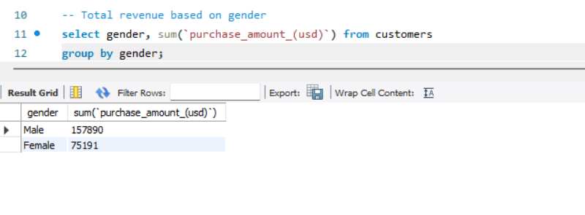
-- Which customers used a discount but still spent more than the average purchase amount? 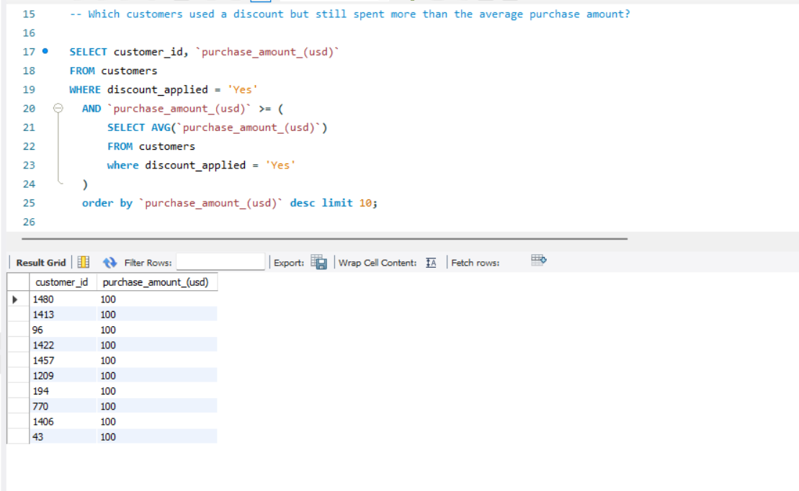
top 5 products with highest average review rating
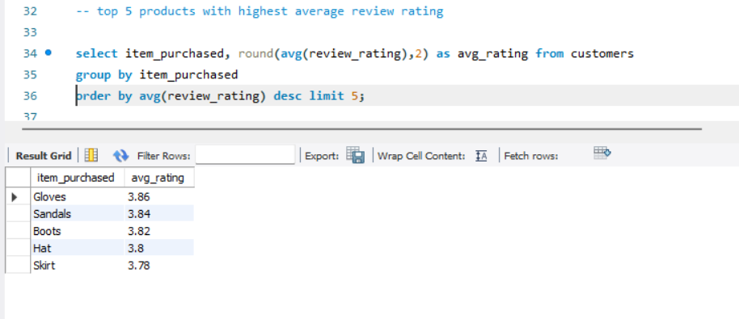
Compare the average purchase amount betwen standard and express shipping.
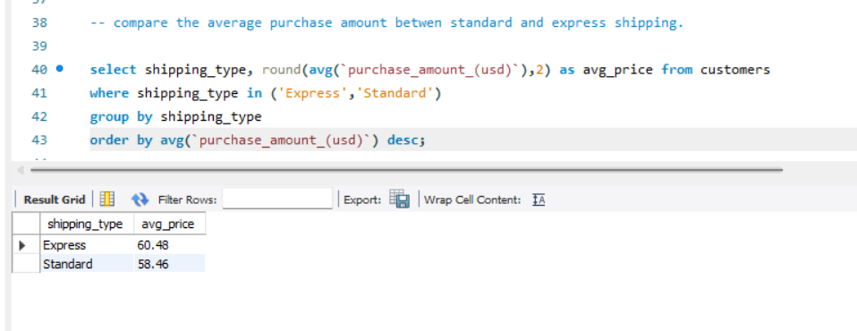
subscribed customer spend more? compare average spend and total revenue between subscriber and non-sub
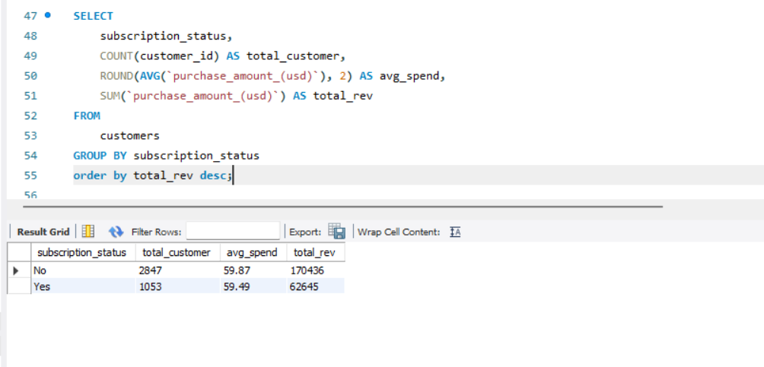

which 5 products have the highest percentage of purchases with discount applied
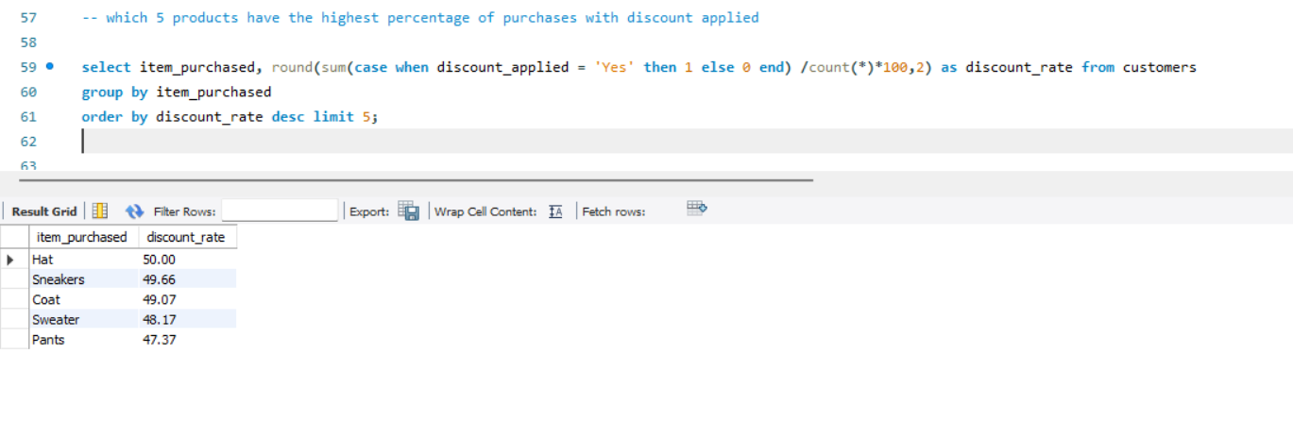
segment customer into new, returning and loyal based on their total number of previous purchase, and show the count of each segment.
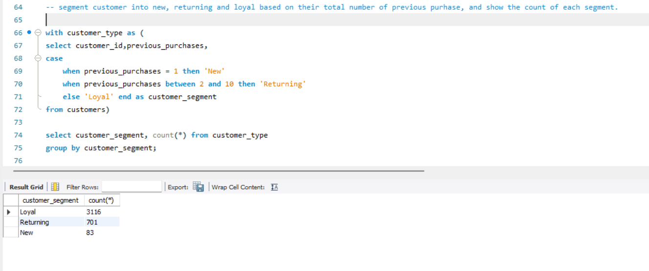
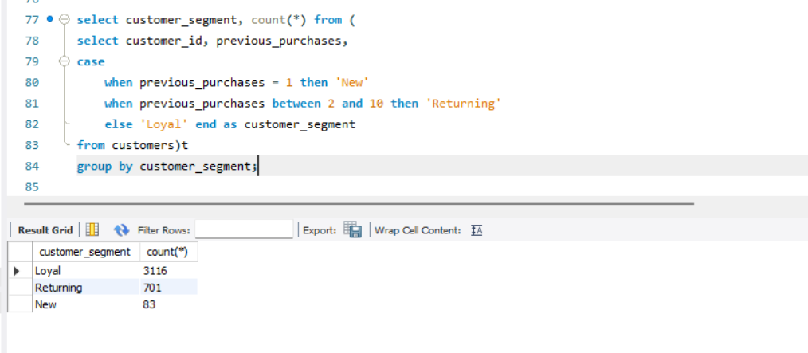

-- what are the top 3 most purchsed products within each category?
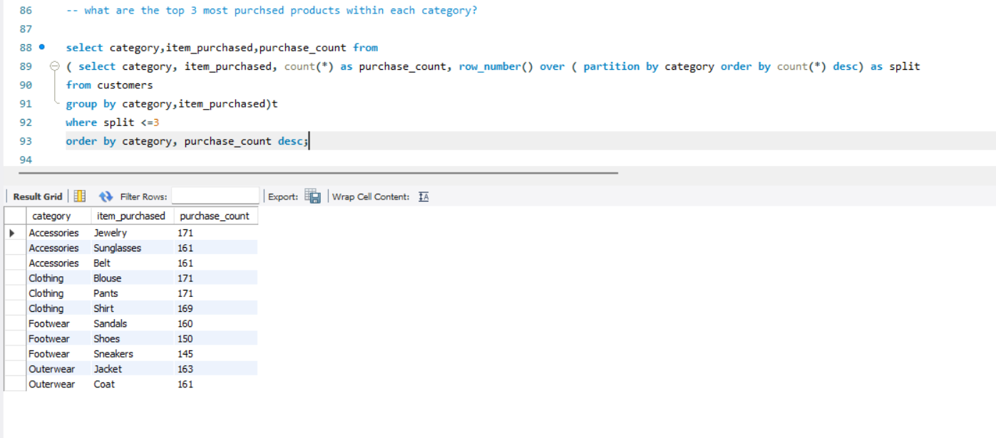
-- Are customer who are repeat buyers (more than 5 previous purchases) also likely to subscribe?
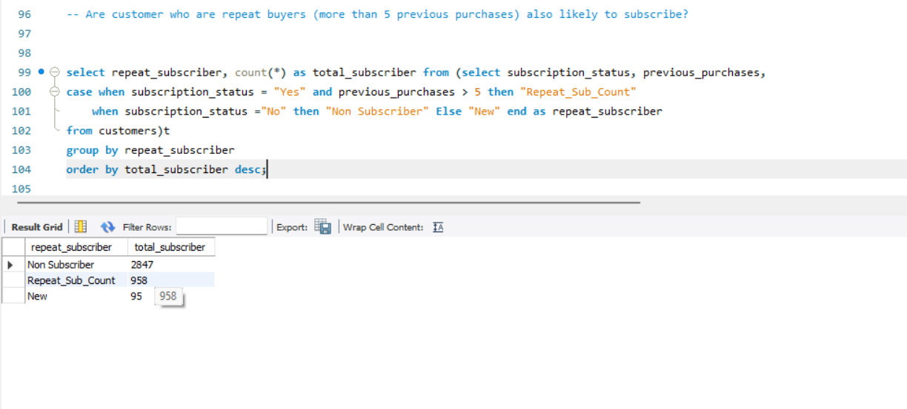
what is the revenue contribution of each age group?
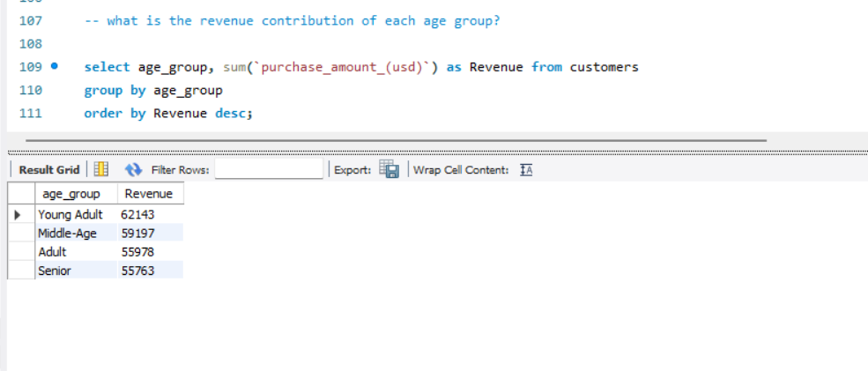
which city is visiting store frequently
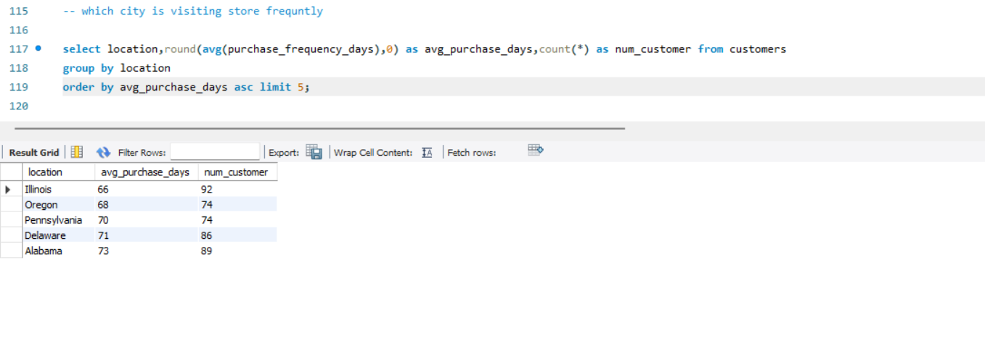
which season have highest sales
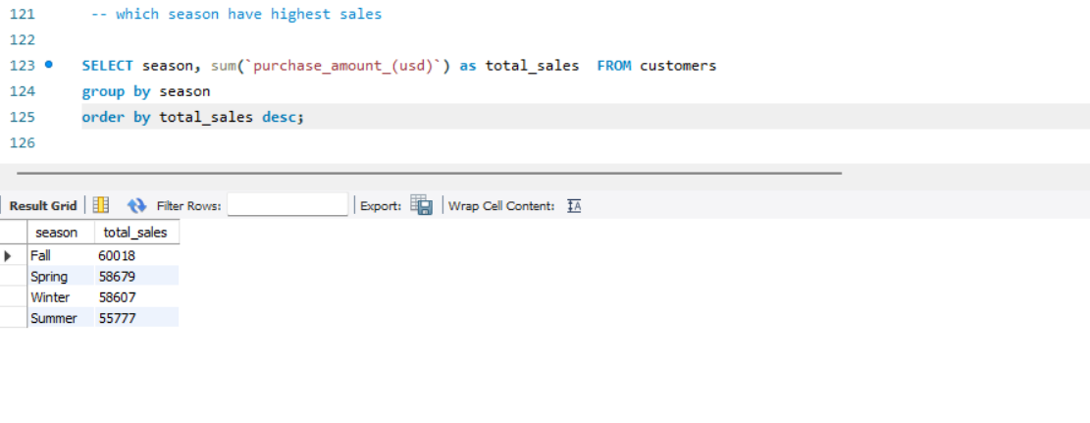

Findings:
Business Performance Overview:
Revenue by Gender: Male customers represent the largest revenue share, contributing $157,890, compared to $75,191 from female customers.
Seasonal Trends: Fall is the peak shopping season with total sales of $60,018, followed closely by Spring and Winter.
Shipping Impact: High-intent customers slightly favour Express Shipping, which carries a higher average purchase value ($60.48) compared to Standard Shipping ($58.46).

Customer Segmentation & Loyalty
Retention Status: The vast majority of the database consists of Loyal customers (3,116), while 83 are identified as New (first-time) shoppers.
Subscription Behaviour: Subscribed customers do not necessarily spend more per transaction (avg. $59.49) compared to non-subscribers (avg. $59.87), suggesting that current subscription perks may drive frequency rather than basket size.
Repeat Buyers: Out of the subscriber base, 958 customers are "Repeat Subscribers" (more than 5 previous purchases), showing a healthy core of brand advocates.

Product & Inventory Insights
Top Performers: Gloves (3.86) and Sandals (3.84) hold the highest average review ratings, indicating high product satisfaction in these categories.
Discount Sensitivity: Hats and Sneakers have the highest discount-driven purchase rates (approx. 50%), suggesting these items are highly price-elastic.
Category Leaders: In Clothing, Blouses and Pants are the volume leaders, while Jewellery dominates the Accessories category.

